**Numerical Fields**

In this dataset there are 14 numerical fields. Table 1 represents some basic statistic summary for each numerical field. Fields that marked in red are fields of low percentage populated.

|  |  |  |  |  |  |  |  |  |
| --- | --- | --- | --- | --- | --- | --- | --- | --- |
| **Field Name** | **Count** | **Unique Values** | **Value with Zero** | **% Populated** | **Mean** | **Max** | **Min** | **SD** |
| LTFRONT | 1,070,994 | 1,297 | 169,108 | 100.00% | 3.66E+01 | 1.00E+04 | 0.00E+00 | 7.40E+01 |
| LTDEPTH | 1,070,994 | 1,370 | 170,128 | 100.00% | 8.89E+01 | 1.00E+04 | 0.00E+00 | 7.64E+01 |
| STORIES | 1,014,730 | 112 | n/a | 94.75% | 5.01E+00 | 1.19E+02 | 1.00E+00 | 8.37E+00 |
| FULLVAL | 1,070,994 | 109,324 | 13,007 | 100.00% | 8.74E+05 | 6.15E+09 | 0.00E+00 | 1.16E+07 |
| AVLAND | 1,070,994 | 70,921 | 13,009 | 100.00% | 8.51E+04 | 2.67E+09 | 0.00E+00 | 4.06E+06 |
| AVTOT | 1,070,994 | 112,914 | 13,007 | 100.00% | 2.27E+05 | 4.67E+09 | 0.00E+00 | 6.88E+06 |
| EXLAND | 1,070,994 | 33,419 | 491,699 | 100.00% | 3.64E+04 | 4.67E+09 | 0.00E+00 | 3.98E+06 |
| EXTOT | 1,070,994 | 64,255 | 432,572 | 100.00% | 9.12E+04 | 2.67E+09 | 0.00E+00 | 6.51E+06 |
| BLDFRONT | 1,070,994 | 612 | 228,815 | 100.00% | 2.30E+01 | 7.58E+03 | 0.00E+00 | 3.56E+01 |
| BLDDEPTH | 1,070,994 | 621 | 228,853 | 100.00% | 3.99E+01 | 9.39E+03 | 0.00E+00 | 4.27E+01 |
| AVLAND2 | 282,726 | 58,592 | n/a | 26.40% | 2.46E+05 | 2.37E+09 | 3.00E+00 | 6.18E+06 |
| AVTOT2 | 282,732 | 111,361 | n/a | 26.40% | 7.14E+05 | 4.50E+09 | 3.00E+00 | 1.17E+07 |
| EXLAND2 | 87,449 | 22,196 | n/a | 8.17% | 3.51E+05 | 2.37E+09 | 1.00E+00 | 1.08E+07 |
| EXTOT2 | 130,828 | 48,349 | n/a | 12.22% | 6.57E+05 | 4.50E+09 | 7.00E+00 | 1.61E+07 |

**Table 1.**

**Categorical Fields**

There are 18 categorical fields included in this dataset. Summary information for each categorical fields is shown as Table 2. Fields that marked in red are fields of low percentage populated.

|  |  |  |  |  |
| --- | --- | --- | --- | --- |
| **Field Name** | **Count** | **Unique Values** | **Most Common** | **% Populated** |
| RECORD | 1,070,994 | 1,070,994 | Uniform Distributed | 100.00% |
| BBLE | 1,070,994 | 1,070,994 | Uniform Distributed | 100.00% |
| B | 1,070,994 | 5 | 4(33.43%) | 100.00% |
| BLOCK | 1,070,994 | 13,984 | 3944(0.36%) | 100.00% |
| LOT | 1,070,994 | 6,366 | 1(2.28%) | 100.00% |
| EASEMENT | 4,636 | 13 | E(89.47%) | 0.43% |
| OWNER | 1,039,249 | 863,348 | PARKCHESTER PRESERVAT (0.58%) | 97.04% |
| BLDGCL | 1,070,994 | 200 | R4(13.06%) | 100.00% |
| TAXCLASS | 1,070,994 | 11 | 1(61.69%) | 100.00% |
| EXT | 354,305 | 4 | G(75.35%) | 33.08% |
| EXCD1 | 638,488 | 130 | 1017(0.1%) | 59.62% |
| STADDR | 1,070,318 | 839,281 | 501 SURF AVENUE(0.08%) | 99.94% |
| ZIP | 1,041,104 | 197 | 10314(2.36%) | 97.21% |
| EXMPTCL | 15,579 | 15 | X1(44.37%) | 1.45% |
| EXCD2 | 92,948 | 61 | 65777(6.1%) | 8.68% |
| PERIOD | 1,070,994 | 1 | FINAL | 100.00% |
| YEAR | 1,070,994 | 1 | 2010/11 | 100.00% |
| VALTYPE | 1,070,994 | 1 | AC-TR | 100.00% |

**Table 2.**

**FULLVAL** represents total market value of the property. The graph shows the log scale distribution of FULLVAL with value limited to one billion.

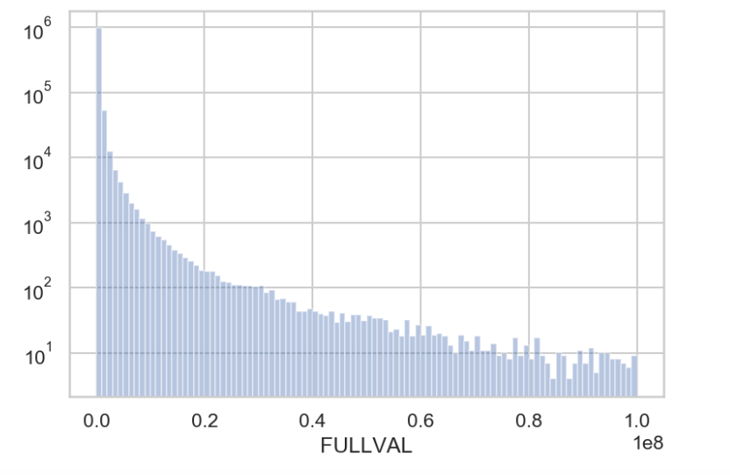

**AVLAND**

**AVLAND** is the land value. The following is the log scale distribution of **AVLAND** with value limited to 10 million.

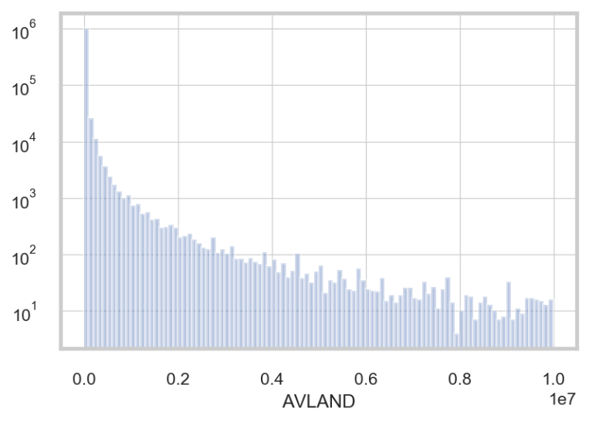

**AVTOT**

**AVTOT** is the land value. The following is the log scale distribution of **AVTOT** with value limited to one billion.

